A 94 GHz Radiometer System-on-Chip With Measured 38ºK NEdT in 65nm CMOS Technology for Future Earth Science Observations

*Abstract* — this paper presents a 94 GHz system-on-chip radiometer for Earth science based on Dicke switched double correlated sampling, and accumulation in the digital domain. The demonstrated radiometer is digitally controlled and calibrated over a single USB connection. The radiometer module was tested using hot and cold loads (liquid N2) and shown to have a measured NEdT of 38ºK. The radiometer SoC itself consumes 171 mW, while the entire testing module with support components consumes 260 mW. Despite lower NEdT performance vs. III-V instruments, the demonstrated radiometer is valuable for Earth science observations from small platforms (CubeSats, UAVs, Balloons) where size, weight and power are extremely limited.

Index Terms — Radiometer, Passive Imager, Measured NEdT

1. Introduction

Although NASA is best known for its exploration of the solar system and human space activities like the international space station, the agency also performs a tremendous amount Earth observation related to monitoring the effects climate change on our environment. Key to Earth science observations are mm-wave radiometers for remote sensing and sounding, especially at low-V (~50 GHz), mid-W (~95 GHz) and high-J band (180 GHz) where O2 and H20 (two key climate indicators) offer strong absorption lines**[1]**. Radiometers are passive instruments that essentially provide an accurate estimate of “in-band received power” and can be used to see the contrast of water or other absorption in the atmosphere blocking the blackbody radiation of the warm Earth in the background. Typical measurements performed with these radiometers are soundings of circus clouds to study formation and refine forecasting models, 2D and 3D temperature and water vapor profiles vs. altitude or geographic position, direct measurements of rainfall and other precipitation, as well as studying the flow of moisture in atmospheric transport between the troposphere and stratosphere. Beyond forecasting models and analysis of long term climate change, radiometers also provide an avenue to study extreme weather events such as hurricanes, tropical cyclones and other severe storms through direct observation of water in all phases (cloud ice, liquid and vapor) and its distribution throughout a storm structure. Studying storm structures provides a major challenge to NASA, as shown in Fig 1, typical satellite-based observations are too sparse in geo-location and in time to provide high-fidelity measurements

of severe storms which can develop anywhere at any time with short durations of a few hrs. To address this NASA and other agencies have proposed large constellations of smaller observation platforms, possibly Cube-satellites, UAVs or even weather balloons, that could collectively provide the spatial and temporal resolution required to capture and resolve severe storms by providing near continuous geo-spatial coverage.

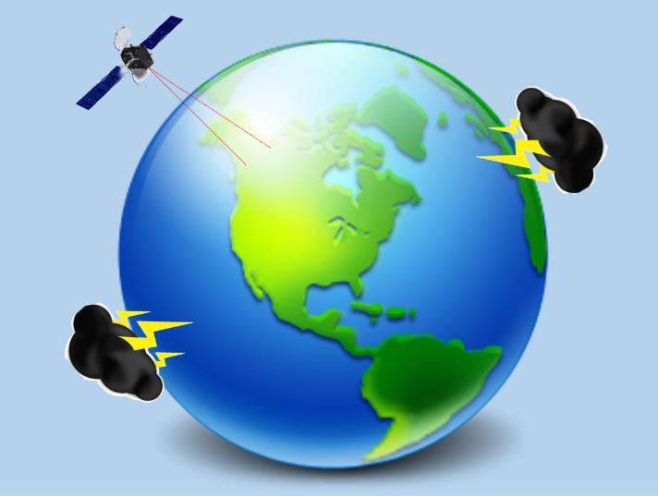

Fig 1. A single large spacecraft or satellite cannot provide the coverage necessary to monitor and diagnose severe storms.

Smaller platforms like Cube-Satellites and UAVs although a potential solution to storm diagnosis, offer extremely restricted payload size, weight and power (typically 1000 cm3 / 1 Kg / 10 W) which cannot accommodate the currently flown radiometers implemented in III-V discrete devices. For this purpose JPL and UCD and have begun to investigate implementation of mm-wave radiometers in CMOS technology as a potential avenue to reduce the size weight and power consumption to levels compatible with these smaller observational platforms. While several groups have already reported excellent CMOS and SiGe receivers **[2,3,4]** that could eventually be used within a radiometer instrument, none have yet implemented a complete system and quantified both the temperature resolution and contrast attainable through measurement. In this work we present the implementation of a complete radiometer system with CMOS receiver and for the first time reported, directly characterize its attainable contrast and temperature resolution (expressed as noise equivalent delta temperature or NEdT).

1. radiometer system architecture

A block diagram of the radiometer module developed by UCD, and JPL is shown in Fig 2. At the core of the radiometer is a CMOS System-on-chip (SoC) implemented in 65nm CMOS technology which contains the receiver chain, power detection, baseband amplification and digital calibration circuitry.

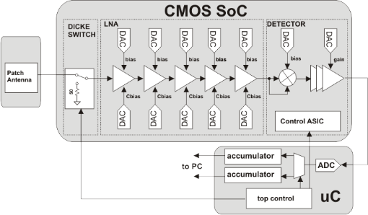

Fig 2. Block diagram of entire radiometer module with CMOS SoC based receiver and power detection with external microcontroller to provide digitization/accumulation.

Each stage of the low-noise amplifier (LNA) is digitally calibrated via a pair of R2R DACs controlled by a central control ASIC (which links to either a PC or a spacecraft’s C&DH processor). Outside the SoC, a microcontroller co-located on the same PCB provides the ADC required to digitize the power detector output, the accumulation/readout functions and control for the dicke switch inside the radiometer SoC. The radiometer’s antenna is implemented as a simple patch antenna fabricated on a Rogers substrate and wire-bonded to the CMOS chip. Fig 3 show a close up photograph of the micro assembly. Additionally the PCB provides all the voltage regulation for bias voltages and SoC supplies from the 5V carried on the USB interface used for data readout operations.

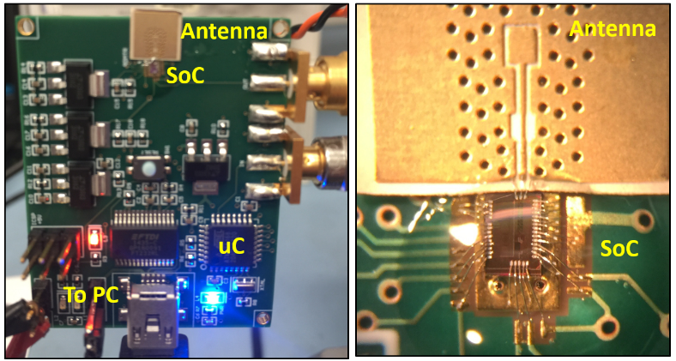

Fig 3. Photograph of overall radiometer module assembly and micro-photograph of antenna and SoC chip assembly.

1. radiometer correlated double sampling

The major challenge of building highly sensitive radiometers is the undesired sensitivity to time varying changes of the receiver’s gain (often called gain drift) which corrupt the final measurement. Unlike additive noise, gain drift cannot be removed through longer integration times or averaging as the transfer function of the receiver itself has shifted during the observation period, meaning that µ=0 (the underlying assumption of averaging to remove noise) is no longer valid, and continued observation will not converge to a zero error estimate of input power. Gain drift can be caused by a number of external sources (thermal instability, mechanical vibration of connectors) as well as electrical sources like flicker noise. Although flicker noise is itself a zero mean phenomenon, the time constants are much longer than the observation periods and so its effects still manifest as gain drift in collected radiometer data. As CMOS flicker noise is quite high compared with III-V technologies, the gain drift cannot be ignored as the resulting measurement error can easily be larger than the temperature difference the instrument is trying to resolve.

**calibration_accum=0;**

**measure_accum = 0;**

**for (counter=1;counter<integration_count;counter++){**

**dicke_switch = calibration_side;**

**calibration_accum= calibration_accum + ADC_in;**

**dicke_switch = measurement_side;**

**measure_accum= measure_accum + ADC_in;**

}

**final_output = measure_accum – calibration_accum;**

}

Fig 4. Coding section used to operate the dicke switch and provide the necessary correlated double sampling to remove the effects of gain drift from the radiometer.

To solve this we use a method of double-correlated sampling where a switch is placed in front of the receiver chain and selects between a known load and the antenna input. This is often referred to as a Dicke switch (named after Robert Dicke, an astronomer who from 1940-1960 developed radio-telescopes and determined the theoretical temperature bounds of the cosmic microwave background). As Robert Dicke first noted in 1946, adding this switch allows us to remove the effects of gain drift by measuring a known load (calibration measurement) to de-embed the changes in gain from our real measurements. By rapidly interleaving the measurements with the calibration, we can generate two highly correlated data sets (provided the time constants associated with the gain drifts are much longer than our interleaving time). In our radiometer this operation is implemented in software running on the microcontroller by the code shown in Fig 4. The parameters of integration_count can be varied to improve sensitivity at the cost of acquisition time, but only to the point where the two accumulators (in this case 32 bit integers) begin to overflow. For the below measurements we used 2000 cycles for our integration_count value.

Fig 5. The structure of the passive imager front end circuits and the corresponding LNA and detector schematic

1. low noise amplifier and dicke switch design

Figure 5 presents the proposed radiometer RF/analog front end, which includes an input balun, differential LNA and power detector with on-chip Dicke switch implemented as a shunt NMOS to ground [2]. To reduce insertion loss, the Dicke structure with no transistor along the signal path is adopted as shown in Figure 5. A fully differential LNA architecture is employed to suppress common mode and supply ripple/noise at the cost of extra power consumption. The input balun serves as the conversion from single-ended to differential signals as well as the input matching network. Figure 5 also sketches the LNA schematic, which features four-stage amplification and adopts fully differential, common source cascode structure. Transformer based inter-stage coupling and matching are utilized for compact implementation. Cascode structures provide the benefits of higher amplifier stability through input and output isolation. To alleviate stray capacitance at the cascode internal nodes, series transmission lines are inserted to tune out the parasitic capacitance. To facilitate non-coherent power detection while suppressing carrier frequency, a differential detector structure is adopted, with the schematic shown in Figure 5. Differential detectors also offer better common mode rejection and coupling noise suppression related to the supply and ground nodes.

1. measurements of radiometer system

In order to characterize the radiometer, we first implemented additional PC software which can read the radiometer’s output value on a continuous basis, and then performed a series of hot and cold load tests using liquid nitrogen and absorber material. In the first test, the Dicke switch was forced to the on position and the absorber soaked in liquid nitrogen was placed in front of the antenna after the radiometer’s output had already been recorded for 20 seconds. After the nitrogen is introduced the output is recorded for 20 more seconds to provide a clear baseline output noise power. The liquid N2 quickly evaporates returning the input temperature to the room temp of 293ºK. Fig. 7 shows the plotted radiometer output during this test (with the N2 introduced at t=20 seconds). Using this measurement and noting the contrast between the liquid nitrogen (boils at 77ºK) and the background level (293ºK) we can directly compute the Y-factors to provide an estimate of noise performance.

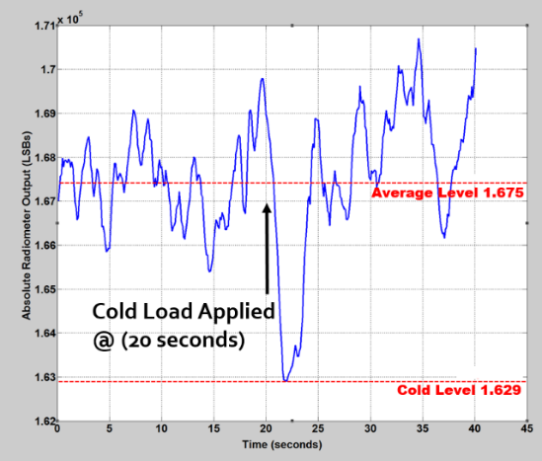

Fig 6. Output of the radiometer during a 40 second test when an absorber soaked in liquid N2 is placed near the antenna at t=20 seconds.

By first taking the mean of the digital output codes when the nitrogen is not applied (1.675x105) then looking at the digital code when the cold load was applied (1.629x105), and understanding that this difference represents (293 – 77 ºK) of temperature contrast, we can extrapolate the total system temperature of the radiometer to a value of 7650ºK. Using the IEEE specified temperature for noise factor/figure (23ºC) we can compute the overall noise figure of the radiometer system to be 10log(7650/293) = 14.1 dB. Second, to demonstrate the entire radiometer operation including the Dicke switch, we again perform a 40 second measurement without changing the input temperature. In this test the calibration and actual radiometer measurements interleaved at 500 kHz. The 500 kHz measurement rate represents 5% of the 10 MHz clock used to drive our microcontroller. The 0.05 factor is applied to the full clock frequency because the microcontroller executes a total of 20 assembler instructions for each cycle of the Dicke switch operation. Figure 7 shows the captured output of the radiometer with the interleaved calibration and measurement cycles.

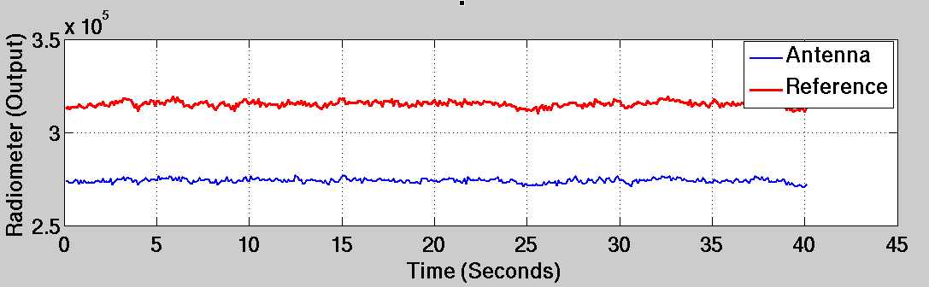

Fig 7. Output of the radiometer during a 40 second test when a constant temperature is applied to the input antenna.

The first and most obvious issue is that the output levels are very different for the calibration and measurement side of the Dicke switch. This is likely due to impedance differences between the two poles of the switch. If we assume the mismatch is a simple gain error, it can be directly corrected in software by first normalizing both accumulators, and then scaling the measurement data by the ratio of the means as shown in Fig 8.

**c_mean = average(cal_accum);**

**m_mean = average(meas_accum);**

**scale = m_mean / c_mean;**

**final_output = (meas_accum)/m_mean – scale*(cal_accum/c_mean);**

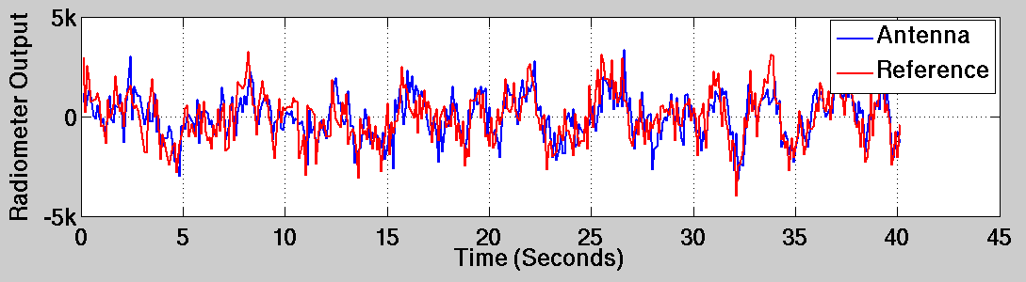

Fig 8. Adjustment to calibrate for gain mismatch between calibration and measurement data of the Dicke switch, and resulting plot.

Third, to characterize the overall NEdT we repeat the test and again introduce the liquid N2 soaked absorber at t=20 seconds with the corrections mentioned above applied. Results of this test after a 3 point smoothing filter is applied is shown in fig 9.

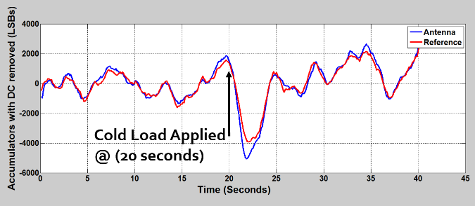

Fig 9. Output of the radiometer during a 40 second test when an absorber soaked in liquid nitrogen is placed in front of the antenna at t=20 seconds with interleaved calibration and measurement cycles.

A second systematic issue that appears in this measurement is the limited isolation between the two poles of the Dicke switch. In an ideal radiometer, only the blue curve should respond to the cold load, while the red remains unaffected as the calibration side should be well isolated from the antenna signal. In the real system, both accumulators respond as the isolation of the Dicke switch is limited at W-band. Correlated double sampling is still possible under this condition as the blue curve (measurement mode) is more sensitive to the temperature change than the red curve (calibration mode) allowing some contrast to exist when the difference is taken.

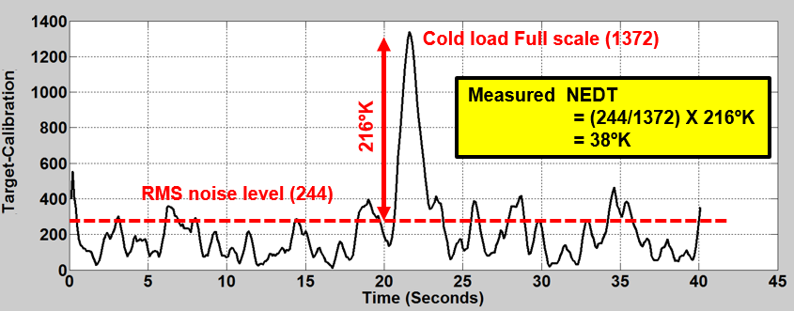

Fig 10. Final output of radiometer when correlated-double sampling is applied. RMS gain drift (noise) level (not counting peak) is shown along with N2 level.

This result is intuitive; the radiometer should be more sensitive when directly connected to the antenna than when it is indirectly coupled through the parasitic capacitances of the switch and surrounding circuitry. Using the data of Fig. 9 and taking the difference provides the final radiometer output shown in Fig 10. By considering the peak response due to the N2 soaked load and remembering that this contrast is again the difference between 293ºK (the room) and 77ºK, we can consider the rms error due to gain drift, and directly compute our resolvable temperature difference (or NEdT), measured to be 38ºK.

1. conclusions

We have presented a CMOS SoC based radiometer and directly evaluated its temperature resolving capability as it relates to Earth science observations. While the demonstrated radiometer functions correctly, the attainable 38ºK temperature sensitivity is somewhat limited compared to existing NASA instruments (typically 2-3ºK), indicating more development is needed. One possible reason is due to the limited isolation from the front end, such as Dicke switch, evidenced from Figure 9. The major limitation of the attainable temperature resolution is neither the noise figure of the receiver, nor the bandwidth of gain drift, but instead is the quality (isolation and matching) of the Dicke switch present at the front of the RX chain. The demonstrated radiometer consumes a total of 260 mW including support circuits. The SoC die photo is shown in Fig 11.

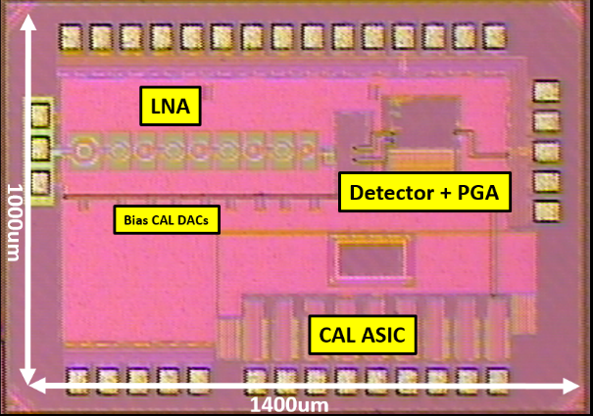

Fig 11. Die photo of radiometer SoC with major blocks identified.

Acknowledgement

The authors are grateful to TSMC for 65nm support. Part of this work was carried out at the Jet Propulsion Laboratory, California Institute of Technology, under a contract with the National Aeronautics and Space Administration.

© California Institute of Technology, 2015.

References

* + - 1. P. Whetton, “Trends in Extreme Weather and Climate Events: Issues Related to Modeling Extremes in Projections of Future Climate Change,” Bull. Amer. Meteor Soc, 81, 427-436.
      2. Qun Gu, et-al, "A CMOS Fully Differential W-Band Passive Imager with <2K NETD", IEEE RFIC 2011.
      3. L. Gilreath, et-al, "A 94 GHz Passive Imaging Receiver using a Balanced LNA with Embedded Dicke Switch", IEEE RFIC 2010.
      4. J. W. May and G. M. Rebeiz, "Design and Characterization of W-Band SiGe RFICs for Passive Millimeter-Wave Imaging," IEEE Trans. Microw. Theory Tech., vol. 58, no.5, May 2010.